***Course No: SWE 430***

***Information and Network Security Lab***

**Assignment on**

**Lab 5: Securing Apache Web Server**

**Submitted To:**

Partha Protim Paul

Lecturer, IICT, SUST

**Submitted By:**

Promi Mojumder

Reg No: 2019831038

IICT, SUST

**Lab 5: Securing Apache Web Server**

**Task-1: Becoming a certificate authority**

1. **Configure openssl.cnf:**
2. Copying the openssl.cnf file from /usr/lib/ssl/openssl.cnf to current directory.
3. Modifying openssl.cnf to suit the requirements, focusing on adjustments within the [CA_default] section to define directories and settings appropriately.

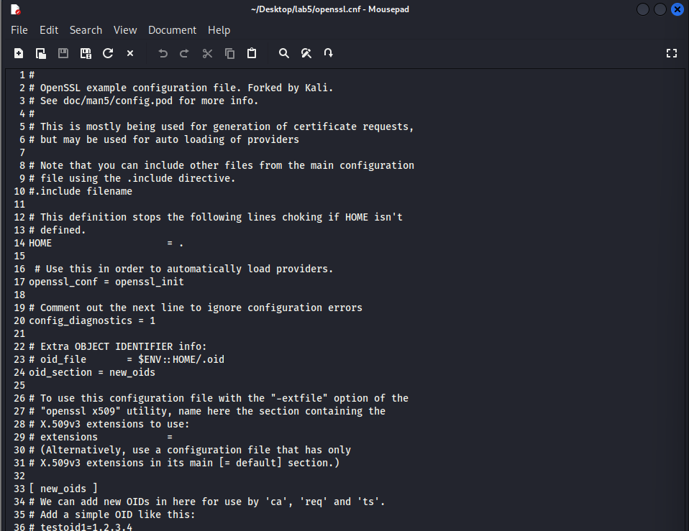

1. **Generating a self-signed certificate for our CA, filling in necessary information such as Country Name, Common Name, etc.**

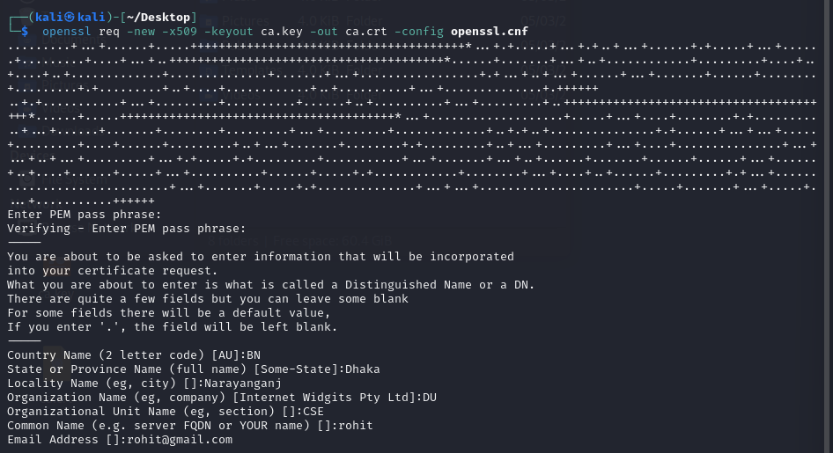

The output of the command is stored in two files: ca.key and ca.crt. The file ca.key contains the CA’s private key, while ca.crt contains the public-key certificate.

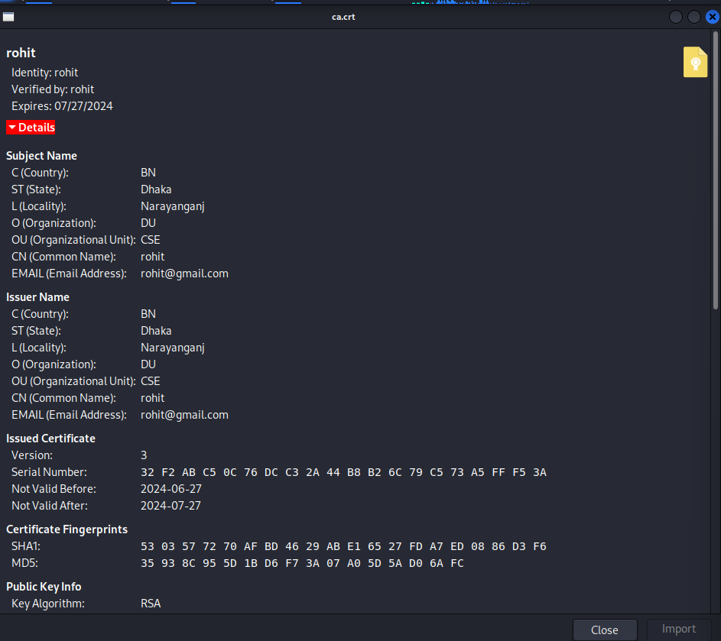

**Task-2: Creating a certificate for example.com**

1. **Generating public/private key pair.**

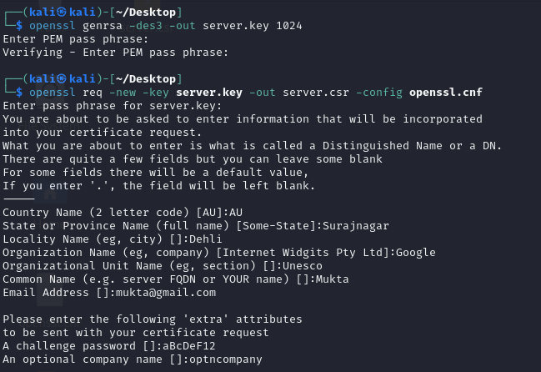

1. **Generating a Certificate Signing Request (CSR).**



1. **Generating Certificates**
2. The names in your requests do not match with those of CA. So, OpenSSL refuses to generate certificates.

1. Fix this and re-issue the above command.

**Task-3: Launching a simple web server with the certificate generated.**

1. **Combining the secret key and certificate into one file.**

1. **Launch the web server using server.pem.**



1. **error message from the browser**

1. **Manually adding our CA’s certificate to the Firefox browser.**

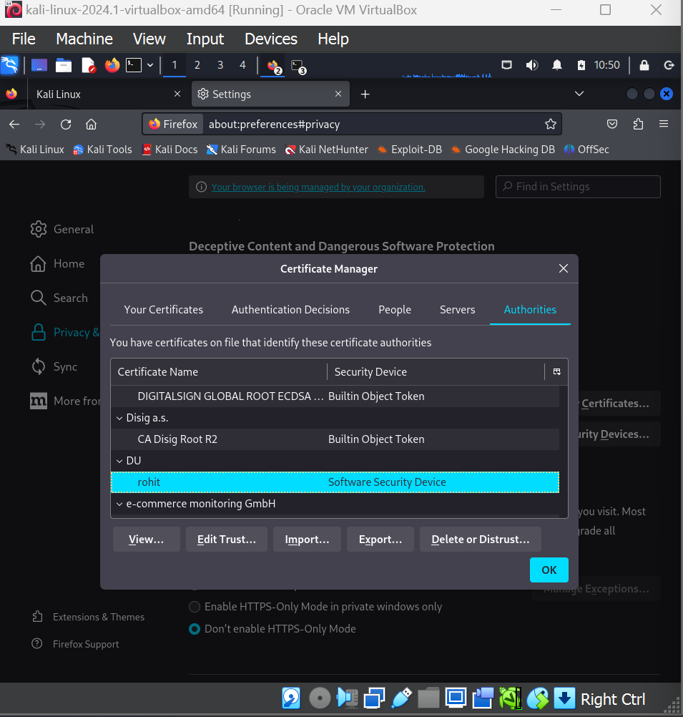

1. **In webpage, showing certificaticates’ details.**

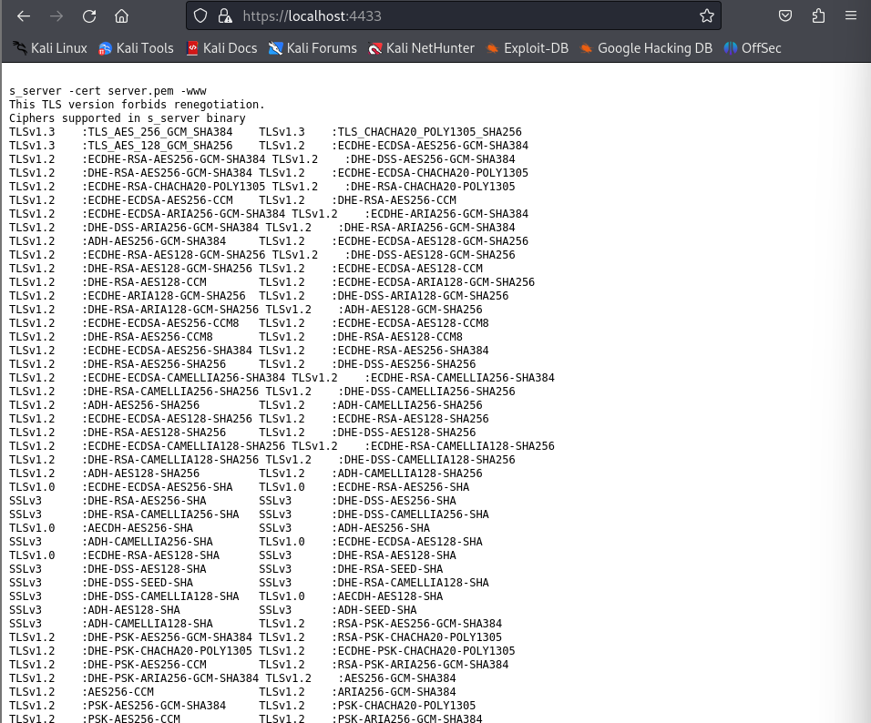

**Task-4: Deploy HTTPS into Apache**

1. **Writing contents in /etc/apache2/sites-available/example.com.conf file.**

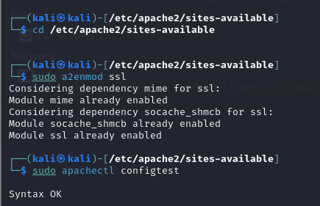

1. **Restarting the apache server.**
2. **Now, try to access the** [**http://example.com**](http://example.com)**. It’ll view the webpage in HTTPS.**

